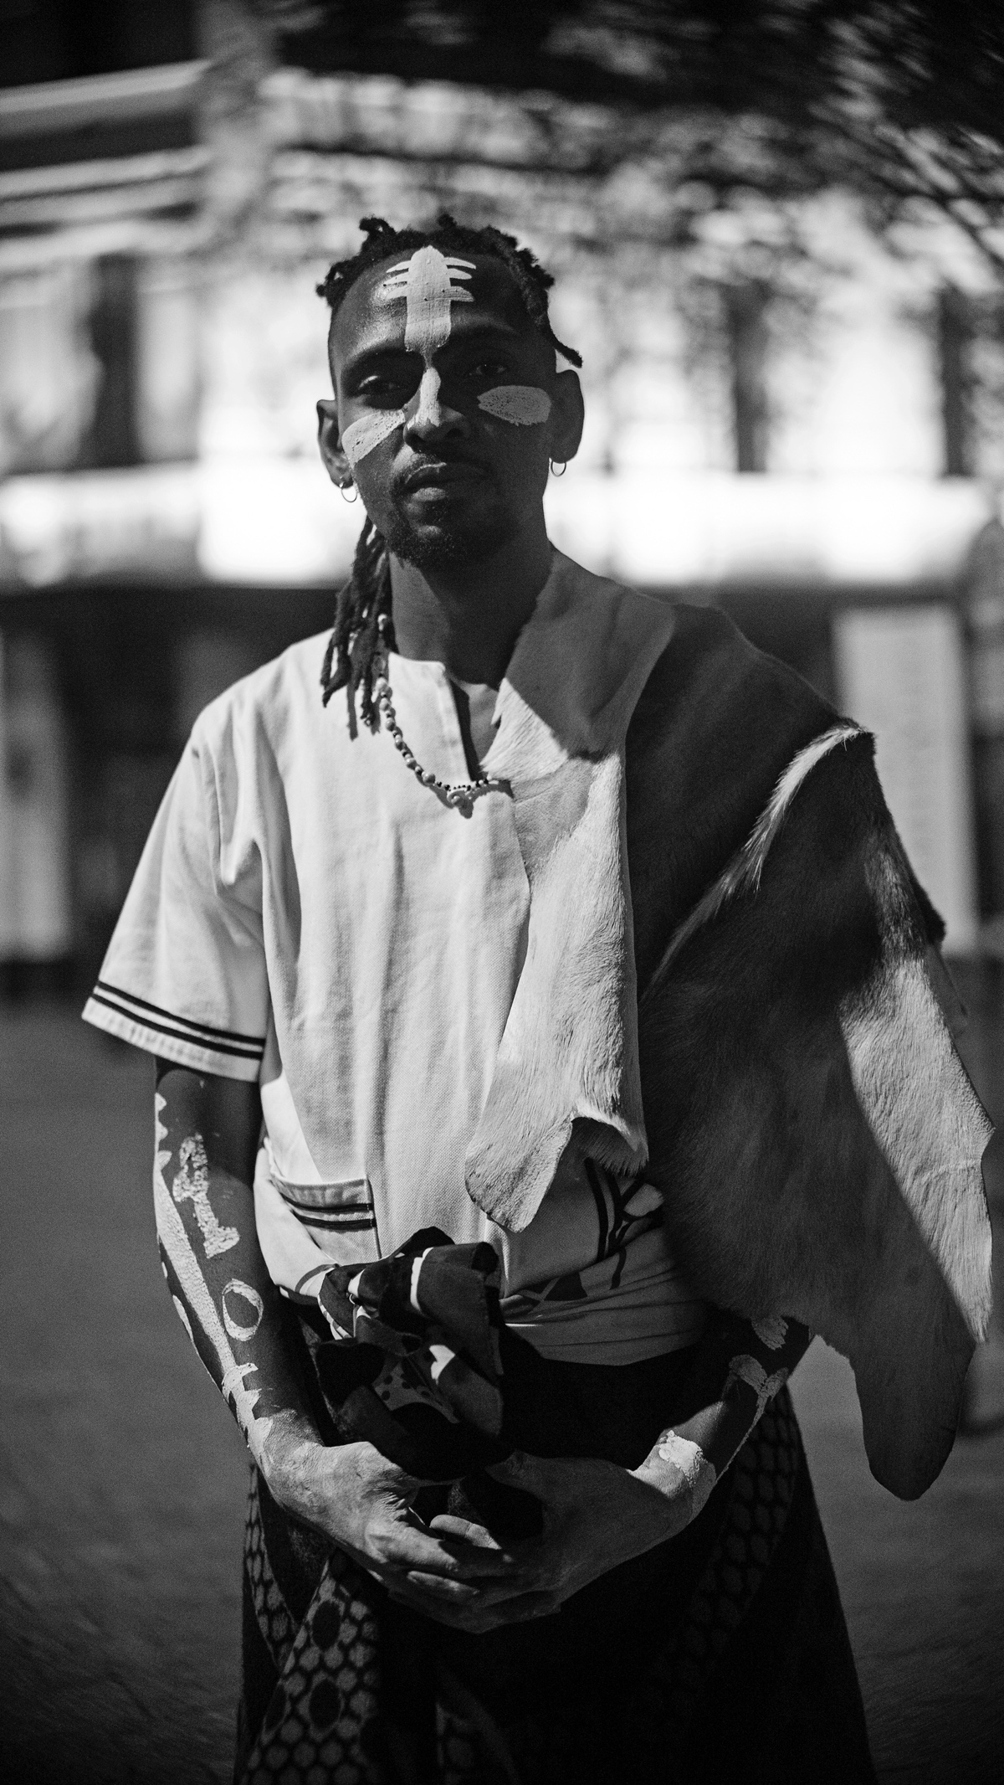
Nkosenathi Ernie Koela (@Mntana.WeXhwele) is a Ph.D candidate specializing in indigenous music therapies at the University of Cape Town. Koela’s Transdisciplinary practice encompasses being an Afrikan Sound artist, sound knowledge teacher, Instrument maker and multi-instrumentalist, he explores how healing practices through sound, creates space that manifests spiritually and materially. Koela has been a performer and instrumentalist for over 18 years and plays multitude of indigenous instruments from around the world. He also teaches others how to make and play traditional instruments with strong emphasis on the instruments h’story, spiritual significance and importance.

This he does as testament to his ancestry, the long line/s of traditional instrumentalists, diviners/ healers (amaGqirha namaXhwele) that run in his family, who are masters of traditional San, Bantu, and Nguni music/heritage. Koela has released 4 Afro-Spiritual collections of dreams and soundscapes: ‘Inkaba’, 2018 Brazil/ Cape Town, Embo Ethongweni (2021) , InKungu and InGuqu (2023).

